Greetings Conference Attendees!

We are excited to have you join us at the AWRA-WA 2019 Annual Conference on October 1st at the Mountaineers Seattle Program Center! For your reference, we have assembled some information that we thought you might find useful.

Conference Location:
Mountaineers Seattle Program Center
7700 Sand Point Way NE
Seattle, WA 98115

https://www.mountaineers.org/about/locations-reservations/seattle-program-center

Registration and Check-in: 7:00 AM to 8:00 AM

Budgeting Driving Time: To be safe, give yourself at least thirty minutes to get from SR520 or I-5 to Sand Point by car. There are several stoplights, and the arterials can get clogged during rush hour. We are starting the conference at 8:00 AM sharp.

Navigating Sand Point: Sand Point has an interesting history, and interesting history makes for interesting navigation. There are three entrances to Sand Point. The Mountaineers facility, circled in red in the map on the next page, is accessed from the entrance in the middle, marked by the red arrow. The north entrance takes you to the NOAA facility (the gray area on the map) via an overpass, and it offers no access to the Mountaineers facility even though the map suggests it would be the fastest way to get there. A photo of the correct entrance is on the next page at bottom left. You drive under the brick building. Remember to turn left immediately after you pass through the building.

Parking: Parking is free and plentiful in the large lot south of the climbing wall on the south side of the Mountaineers facility and along the road. A photo of the climbing wall is below at bottom right on the next page. The entrance to conference registration is on the west side of the building.

Coffee and Food: We are very excited to have Pyramid Catering with us at the conference. Vegetarian and Gluten Free dining options will be available. A continental breakfast will be available before the conference starts. At the first break, coffee and light refreshments will be served. Lunch is buffet style. Additional refreshments will be provided during our afternoon break. We hope you save some appetite and join us for our evening reception, where we will be serving a buffet of Northwest hors d’oeuvres, as well as beer, wine, and other refreshments. The reception will be held onsite beginning immediately after the close of the conference and running until 7:00 PM.

If you have additional questions, please feel free to contact Tom Fitzhugh at thomas.fitzhugh@stantec.com.
See you at the conference!

Tom Fitzhugh
AWRA-WA 2019 Conference Chair

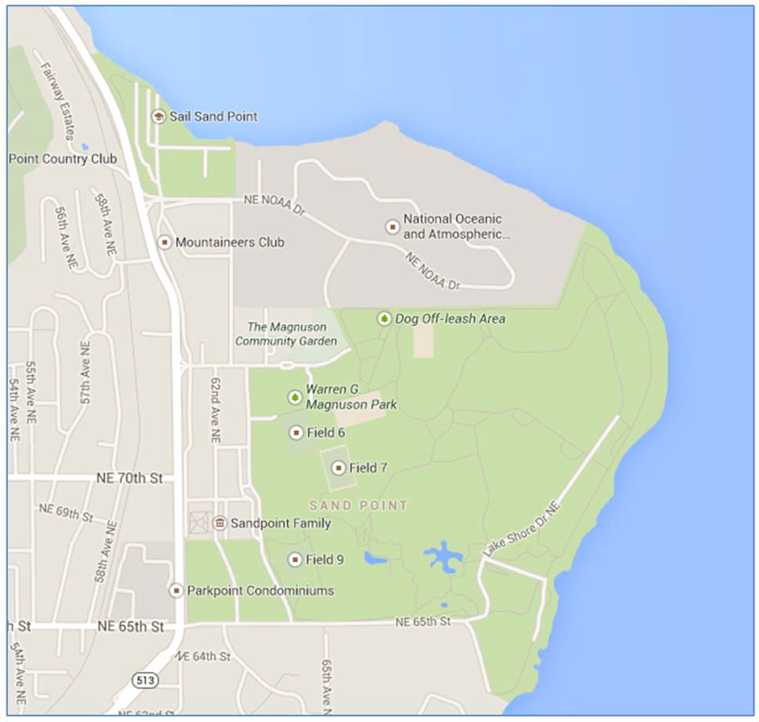
74th Street Entrance

Magnuson Park Entrance Shown Below: Climbing Wall near Parking Area is Shown Below:
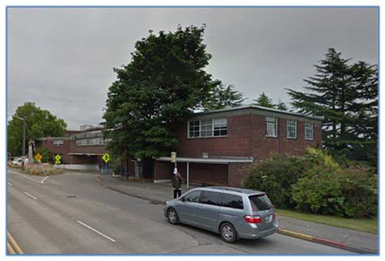
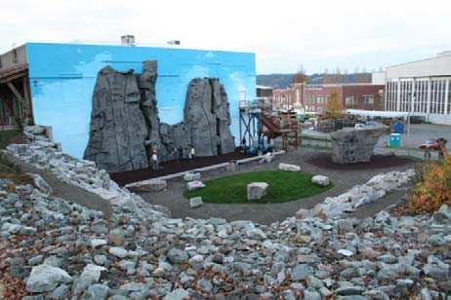

DRIVING DIRECTIONS

FROM STATE ROUTE 520 WESTBOUND or EASTBOUND

- Exit onto Montlake Boulevard:
  - Via SR 520 westbound: after crossing the floating bridge across Lake Washington, take the second exit onto Montlake Boulevard. Stay right and merge onto Montlake Boulevard.
  - Via SR 520 eastbound: after merging onto SR 520 from I-5 (north or southbound), take the first exit to Montlake Boulevard. Stay left on the exit ramp. Turn left onto Montlake Boulevard. Make your way into the right lane of Montlake Boulevard.
- Stay to the right along Montlake Boulevard and continue north about one mile, across the Montlake Cut and past the Husky Stadium and light rail tunnel construction on your right.
- Stay to the right as Montlake Boulevard becomes NE 45th Street.
- Continue straight (east) through the NE 45th/Union Bay Place five way intersection.
- As the street bears to the left (north), it becomes Sand Point Way NE.
- Continue on Sand Point Way NE for approximately two miles. Go past the 65th Street entrance to Magnuson Park on your right.
- About 0.5 miles past the first Magnuson Park entrance on 65th Street, you will pass a 7-Eleven on your left. The 74th Street entrance to Magnuson Park will be on your right. Take this entrance to the right, going through a tunnel in a two story brick building (image of entrance on previous page).
- Go past the unstaffed ticket booth.
- Take an immediate left just past the booth onto an unnamed road.
- Proceed along the unnamed road to the parking lot. The Mountaineers facility is ahead of you, with the climbing wall on its south side. Park in the lot in front or beyond the building. The conference entrance is on the west side of the building that faces Sand Point Way NE.

DRIVING DIRECTIONS

FROM I-5 via NE 45th Street

To be safe, give yourself at least thirty minutes to get from I-5 to the conference. There are several stoplights, and the arterials can get clogged during rush hour.

- Take the NE 45th Street Exit (Exit #169).
- At the stoplight, go east on 45th, past the University of Washington and down the 45th Street ramp.
- Continue straight (east) through the NE 45th/Union Bay Place five way intersection.
- As the street bears to the left (north), it becomes Sand Point Way NE.
- Continue on Sand Point Way NE for approximately two miles. Go past the 65th Street entrance to Magnuson Park on your right.
- About 0.5 miles past the first Magnuson Park entrance on 65th Street, you will pass a 7-Eleven on your left. The 74th Street entrance to Magnuson Park will be on your right. Take this entrance to the right, going through a tunnel in a two story brick building (image of entrance on previous page).
- Go past the unstaffed ticket booth.
- Take an immediate left just past the booth onto an unnamed road.
- Proceed along the unnamed road to the parking lot. The Mountaineers facility is ahead of you, with the climbing wall on its south side. Park in the lot in front or beyond the building. The conference entrance is on the west side of the building that faces Sand Point Way NE.

DRIVING DIRECTIONS

FROM I-5 via NE 65th Street

From Northbound I-5:

- Take Exit 170 (Ravenna Blvd / NE 65th Street.)
- Go straight through the intersection with Ravenna Boulevard
- Turn right onto NE 65th Street
- Skip to Continuing from NE 65th Street: below

From Southbound I-5:

- Take Exit 171 (NE 71st Street/NE 65th Street)
- Immediately merge onto 6th Ave NE
- Turn left onto NE 71st Street and proceed over I-5 on the overpass. At the end of the overpass, you’re on NE 70th Street.
- Turn right onto Roosevelt Way NE at the next block
- Turn left onto NE 65th St after five blocks

Continuing from NE 65th Street:

- Head east approximately four miles on NE 65th Street to Sand Point Way NE (stay on the arterial as it hooks right and then left through the neighborhood at the top of the hill. You actually turn right onto NE Princeton Way, which turns back into NE 65th Street after the second bend).

- Turn left on Sand Point Way NE.

- About 0.5 miles past the first Magnuson Park entrance on 65th Street, you will pass a 7-Eleven on your left. The 74th Street entrance to Magnuson Park will be on your right. Take this entrance to the right, going through a tunnel in a two story brick building (image of entrance on previous page).
- Go past the unstaffed ticket booth.
- Take an immediate left just past the booth onto an unnamed road.
- Proceed along the unnamed road to the parking lot. The Mountaineers facility is ahead of you, with the climbing wall on its south side. Park in the lot in front or beyond the building. The conference entrance is on the west side of the building that faces Sand Point Way NE.

BY BUS

Metro bus routes 30, 62, 74, and 75 serve Magnuson Park along Sand Point Way N.E. Connections are in the University District (Routes 30, 62, and 74) and Northgate (Route 75). For schedules and route maps, visit http://kingcounty.gov/depts/transportation/metro/schedules-maps.aspx and search for "Sand Point". To plan a trip to the venue, you can also use the Metro Trip Planner available at http://tripplanner.kingcounty.gov/.

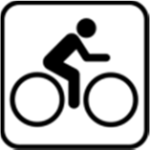

BY BICYCLE

The Burke-Gilman Trail conveniently passes approximately ¼ mile west of the Mountaineers facility. Plan your route with the Burke-Gilman trail map. You can reach the facility by leaving the trail at NE 77th St. and heading east.

